Letters about Employment
Here are a few Useful Phrases for letters about Employment.
Openings:
The standard opening for formal correspondence is Dear.
- Dear Sir
- Dear Madam
- Dear Sir or Madam
- Dear Sirs
- Dear Mr.
- Dear Mrs.
- Dear Ms.
Useful phrases:
- I am writing in response to your advertisement in [publication]
- I am writing to apply for the post of
- Thank you for your letter of [date] offering me the post of
- I am delighted to accept the position of [job title]
- I look forward to starting work with you
Closures:
- Thank you for considering this application
- I should be pleased to attend an interview
- Please do not hesitate to contact me on the above number if you should require further information
- I look forward to hearing from you
If you know the name of the person use: Yours sincerely
If you don’t know the name of the person use: Yours faithfully
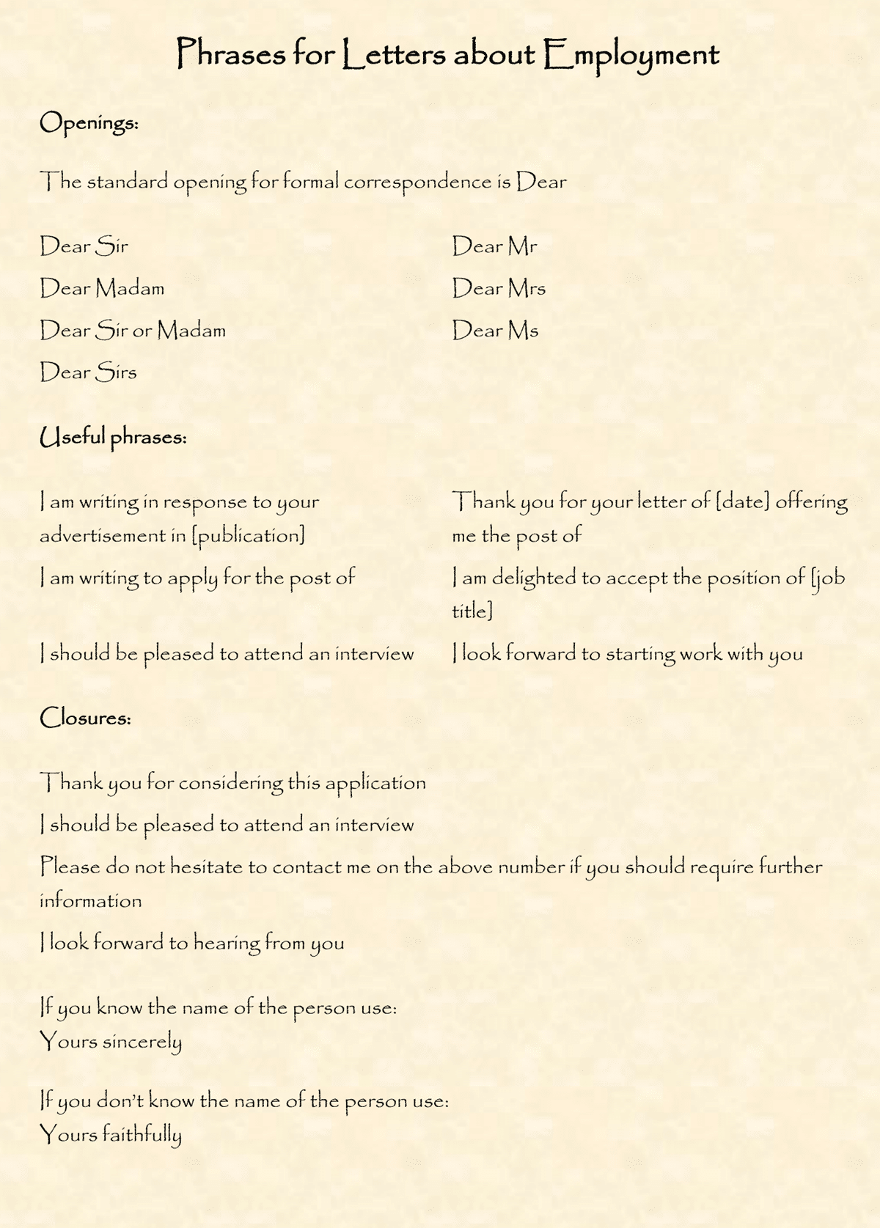

Useful Phrases for Personal and Social Correspondence
Here are a few Useful Phrases for Personal and Social Correspondence.
Openings :
The standard opening for personal correspondence is Dear but variations include:
- My dear …
- My dearest …
- Darling …
Useful phrases:
- Thank you for your letter [inviting, offering, confirming]
- I am very grateful to you for [letting me know, offering, writing]
- It was so kind of you to [write, invite, send]
- Many thanks for [sending, inviting, enclosing]
- I am writing to tell you that
- I am delighted to announce that
- I was delighted to hear that
- I am sorry to inform you that
- I was so sorry to hear that
Closures: For acquaintances and formal situations
- Best wishes.
- With best wishes.
- Kindest regards.
Closures: Affectionate variations for close friends and family
- All my love
- All the best
- Love
- Lots of love
- Much love
- With love
- Love from us both
- See you soon
- Once again many thanks
- I look forward to seeing you soon
- With love and best wishes
- With love to you all
- Do give my kindest regards to …
If you know the name of the person use:
- Yours sincerely
If you don’t know the name of the person use:
- Yours faithfully
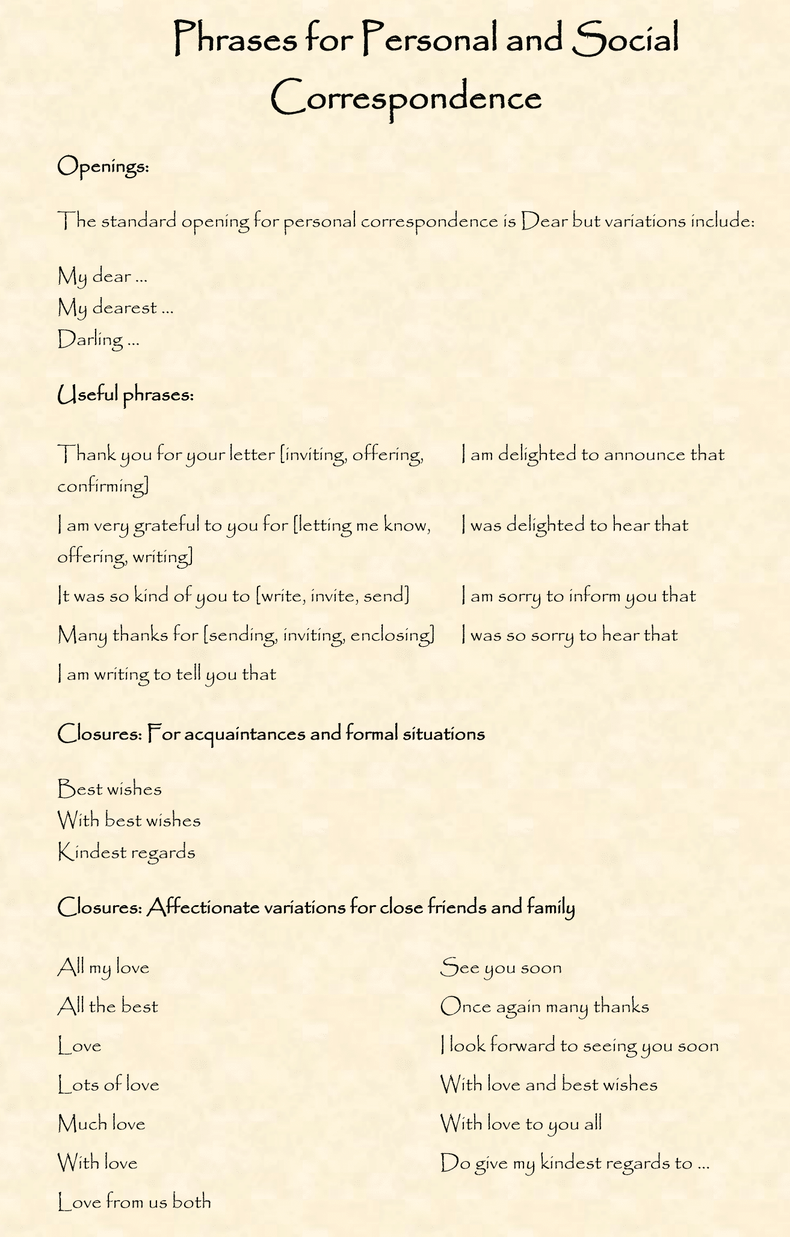

The Writing Process
Questions to consider while growing your writing:
I. Pre-writing: Time to think
– What do I want to say?
– How do I want to say it?
– Who will read my writing?
– Who can I talk to about my ideas?
– Where will I record my ideas?
II. Drafting: Time to write it down
– Are my thoughts organized?
– Which ideas do I want to develop?
– In what order do I want to say them?
– Who can read this and offer suggestions?
III. Revising: Time to improve my writing
– Have I read what I’ve written?
– Are my details clear?
– Should I add or take out parts?
– Have I used the best ideas and words?
– Is my writing in a logical order?
– What suggestions have others given me?
IV. Editing: Time to make things correct.
– Have I used complete sentences?
– Are my spelling, capitalization and punctuation correct?
– Have I marked corrections that I need?
– Has someone checked my work?
– Do I have a corrected copy that I can publish?
V. Publishing: Time to share my writing
– How should I publish this writing?
– Should I illustrate and display it?
– Should I make it into a book?
– Should I read it out loud?

