Who? |  | Do /did
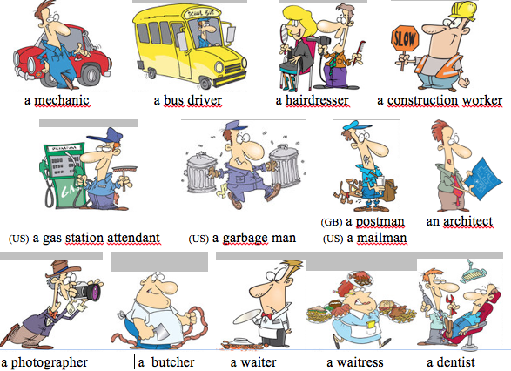 |  | 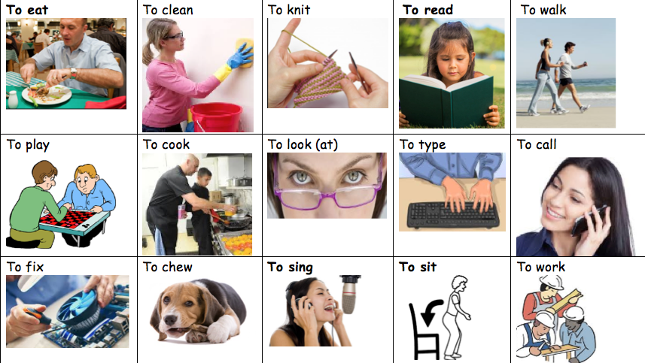
The man  The boy  The cook  My son  The student  My father  His wife  The policeman  The baker  The teacher  The nurse  The doctor  The construction worker  The business man  The truck driver | The woman  The girl  She  My daughter  My mother  Her husband  The postal worker  The mailman  The librarian  The grocery clerk  The store clerk  The pilot  The banker  The bus driver | Present past  is* has walks plays eats runs goes works helps drives cooks studies chews was had walked played ate ran went worked helped built drove cooked chewed | Present Past  reads calls cleans sing builds fixes sits looks at types studied called cleaned and build fixed sat looked at typed
He She |  | _________________s | ______________s

WHAT? WHEN ?
in the morning | in the afternoon | in the evening
at lunch | at night | in the spring
in the summer | in the winter | in June in July …
at 7 o’clock | at 8:30 in the morning | in the autumn
every day  every morning  every afternoon  every night  every year  every month  on the weekend  once a week  once a month  once a day  twice a..  in January  in July….  at Easter  at Christmas | at night during the day  on the 7th of June  on the 2nd of April  on the seventh of June  on the second of April  on June, 7th  on April, 2nd  on June, seventh  on April, second | in the summer in the spring  in the autumn in the winter  in the morning at noon  in the evening at night (at midnight)

