Useful Phrases for writing formal letters
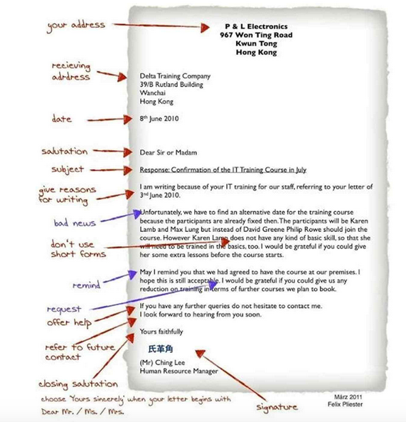FORMAL LETTERS
STARTING
- We are writing you with reference to (the above order).
- With reference to your advertisement/letter of 10 March……
- We are pleased to have your inquiry of 25 of July….
- We acknowledge the receipt of your letter dated 12 April …..
- With reference to your letter inquiring about…
- With reference to our telephone conversation yesterday (about…),…
- We wish to remind you that…..
- I am writing this letter to request the cancellation of……..
- I am writing this letter to complain in the strongest terms about the poor service that I have received from your company.
ACTION
- Please advise us as soon as the…….
- Please open a ………….in favour of (name of the company)……….
- Payment can be made on any basis acceptable to you.
- Could you please supply us with information about the company’s standing.
- We have been informed (by one of our clients) that……….
- We regret to inform you, (however,) that….
- Please accept our apologies for the inconvenience caused.
- We must insist on…
- Please note that the closing date/deadline for the ……… is 30 September, so will you please complete the attached forms and return them as soon as possible.
- Any information you supply will be treated confidentially.
- May we remind you that your statement is still outstanding.
- Will you kindly balance your account promptly.
- We are puzzled to have had no remittance from you.
- You already have an overdraft of….
- Please give the matter your immediate attention.
- We will be left with no alternative but to (take legal action)… unless payment is received within the next seven days.
- Our circumstances do not allow us to wait/to go on waiting any longer.
- Please look into the matter.
- We were dissatisfied to find that….
- We shall have to terminate the contract.
- On examination we have found…
- We greatly appreciated your patience in this matter.

ENCLOSURES AND ATTACHMENT
- We would be grateful if you could forward/send any further information (you may have) about…. (products and terms of payment/this case)
- We will be pleased to supply any further information you require.
- We are sending the herewith the……
- We look forward to doing business to our mutual advantage.
- We would like to make a decision on this as soon as possible.
- In the meantime, we suggest that you call the ………
- We hope to meet your requirements.
- Please send us by return the terms and conditions on …………..
- For purposes of quick contact a reply by telephone would be appreciated.
- We look forward to the opportunity of being at your service.
- Could you please let us know in your earliest convenience whether the above terms and conditions are acceptable for you.
- We hope that the matter will be settled to our mutual satisfaction.
- We very much hope that you will be able to…..
- I would be grateful if you could spare me a few minutes.
- As our demand/request/issue is very urgent, a quick answer would be appreciated.
- Would you (also forward details of charges)………. at your earliest convenience?
- I should/would be pleased if you could send me …….
- We trust/hope you will find this condition acceptable.
- If there is any other information you need, please do not hesitate to contact us at the above e-mail address.
- Thanking you in advance.
- I would be most grateful if you would reply as soon as possible so that this matter can be resolved to everyone’s satisfaction.
- Please find enclosed….
- I am enclosing…….
- Please find attached….
