WHO?  The __________ | Do/did  Does what | WHERE?  to the _________
man boy teenager  woman girl lady  baker teacher doctor  pharamacist father librarian  banker pilot policeman  bartender waiter/waitress store clerk  lifeguard salesman postal worker  cook gardener policewoman  WHERE?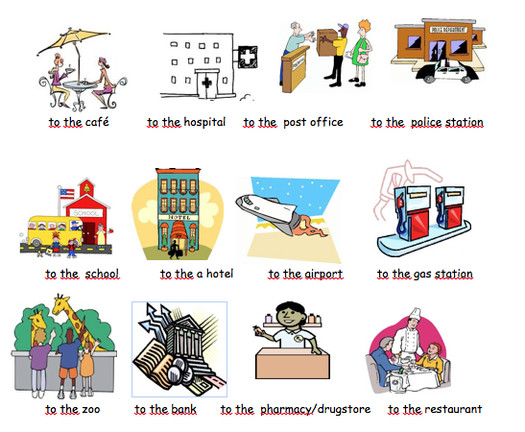 | walks  goes  drives  runs  cycles  takes a subway  takes a train  takes a bus  takes a taxi | 