Where does the ___work?  The __________ | works | ______________.
man boy teenager  woman girl lady  baker teacher doctor  pharamacist father librarian  banker pilot policeman  bartender waiter store clerk  lifeguar actor postal worker  WHO?  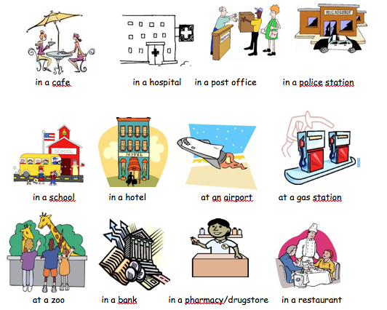 WHERE? |  | 