in the…………. at the ……….in the ………. | WHY?
WHERE? 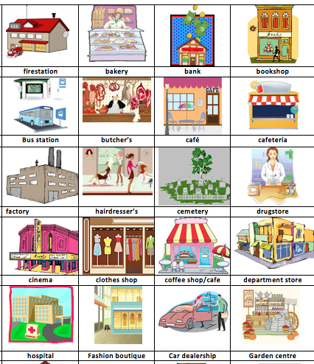 | because…

